Description:

Yesterday I keep tracking on the price of flight ticket from different date and the price of the van, after the discussion, we finally decide to rent a van and drive to NewYork City.

<https://www.justfly.com/flight/search?num_adults=4&seat_class=Economy&seg0_from=COU&seg0_to=JFK&seg1_from=JFK&seg1_to=COU&seg0_date=2017-09-27&seg1_date=2017-09-27&type=roundtrip>. This is the one rating extraordinary high on google.

From Columbia Missouri to New York, United States - John F Kennedy International [JFK]

If we leave from Missouri Columbia at the end of the Sep, Here is the price(one way)

AA: 583.80

United Airline: 591.80

Delta: 830.00

Depart in the middle of Octorbor

AA: 303.7

UA:303.7

Delta: 538.0

2nd option: renting the car, which takes us 17 hours to NewYork City, departing at 4 AM, arrive to New York City at 7 PM

**Dodge Caravan**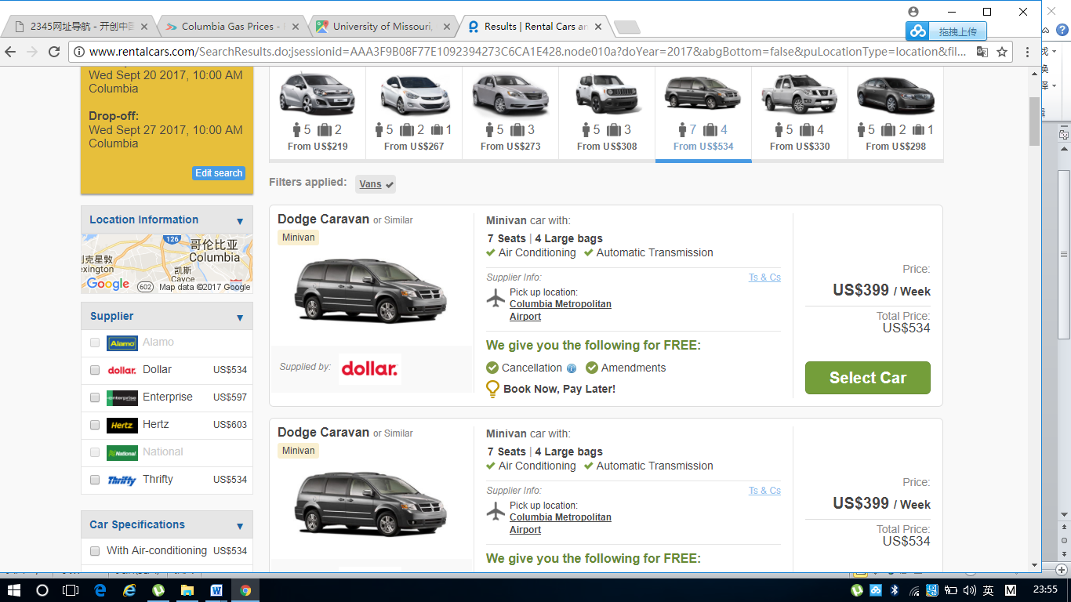

Tank size: 20 gallon

Customer review:

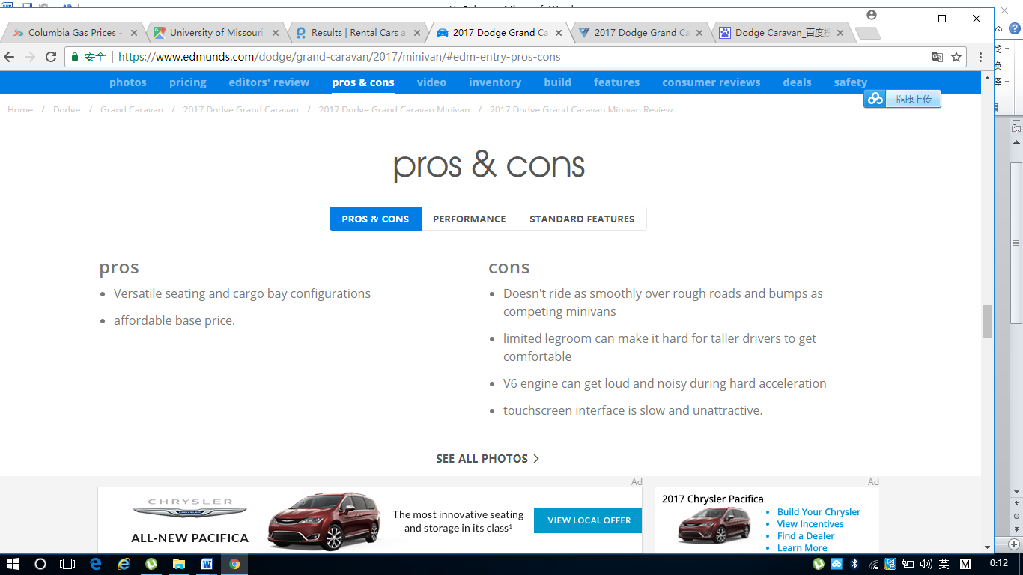

MPG:

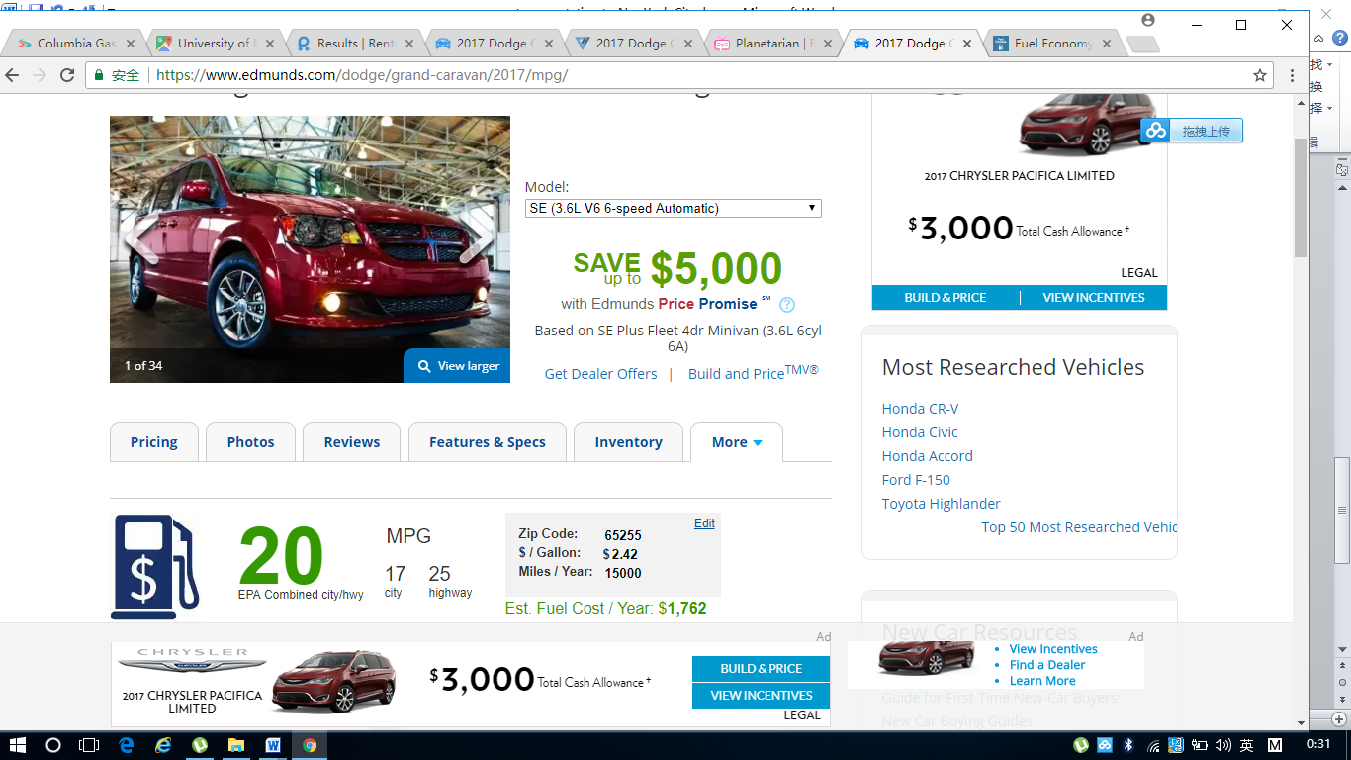

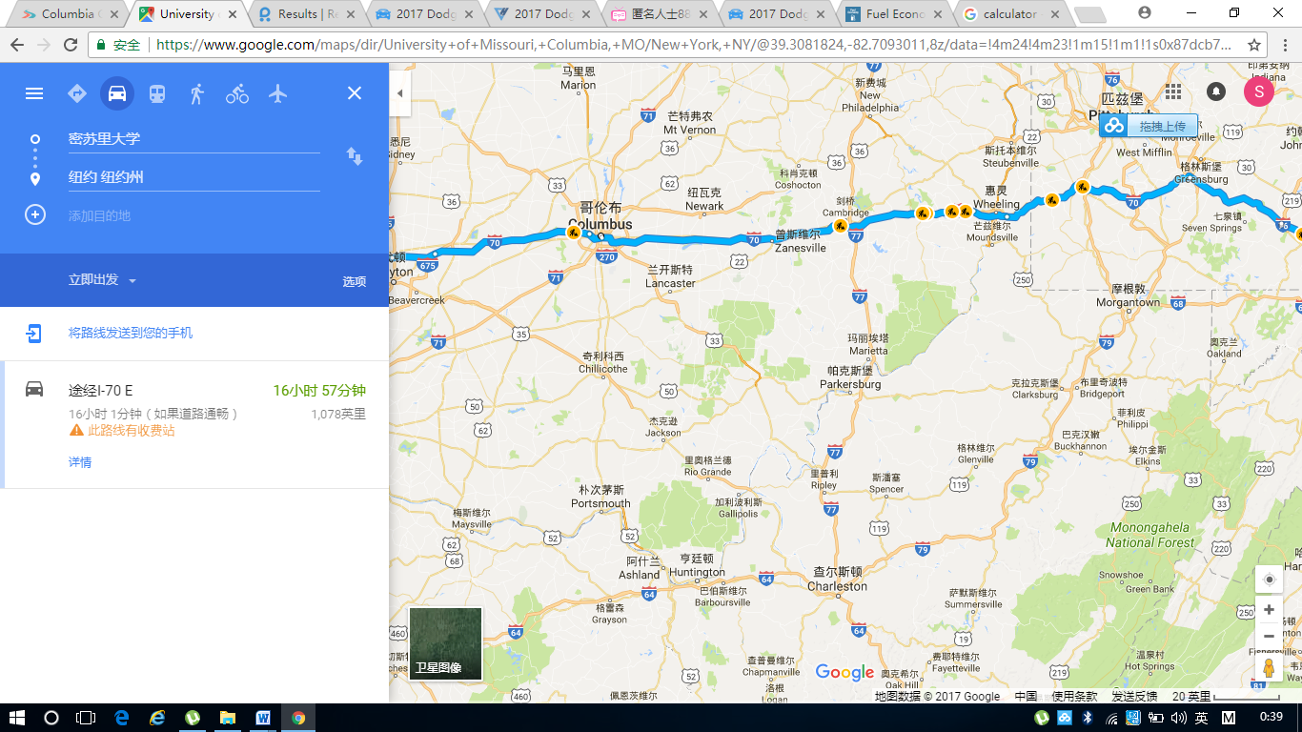

1078 miles

.

So Overall the gasoline will costs (1078/25)*2.42*2 = 104.3504 dollars

Each people needs to pay 104.3504*2/5 = $42

F